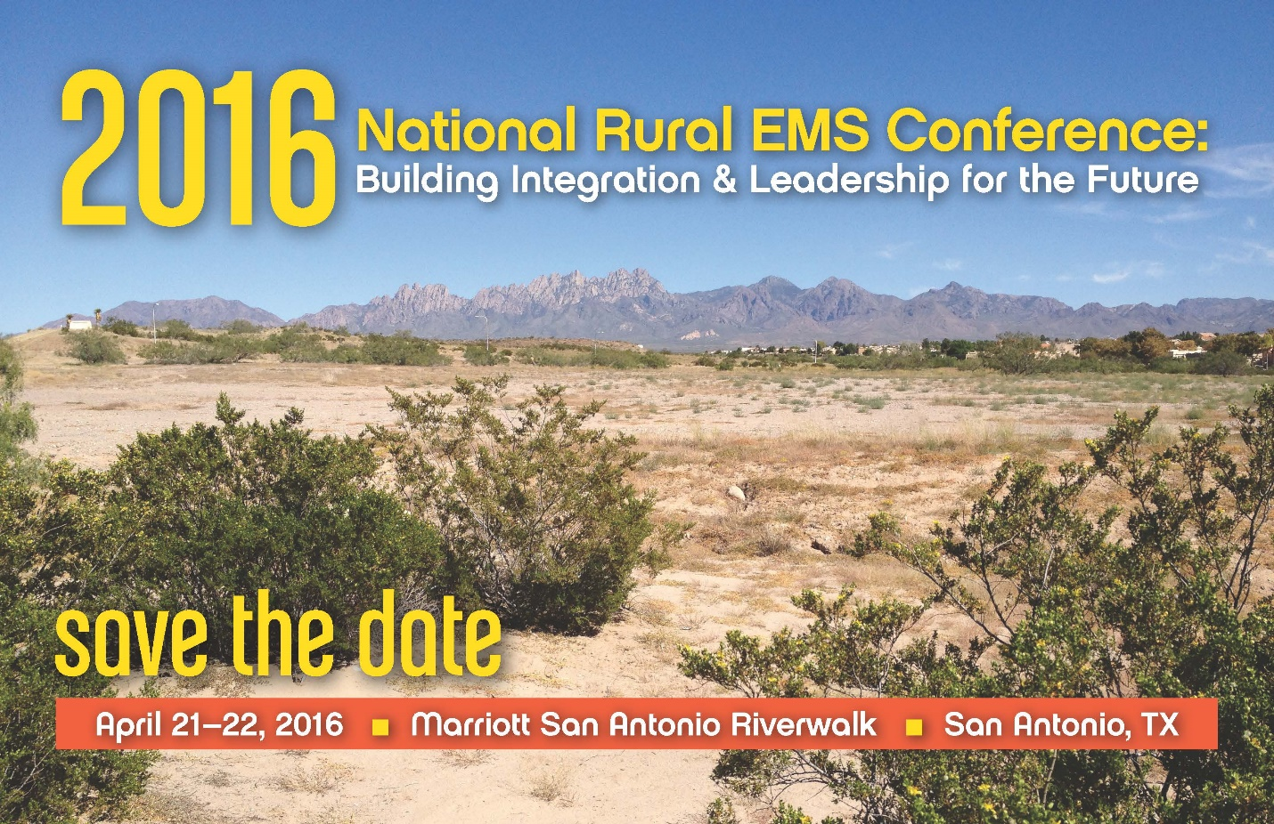

An Invitation to Join Us
The Joint Committee on Rural Emergency Care invites non-profit organizations and corporate partners to attend, exhibit and be recognized at the National Rural EMS Conference: Building Integration & Leadership for the Future in San Antonio, Texas. Exhibitors will have ample opportunity to meet invited guests: rural EMS Directors, state EMS Officials, State Offices of Rural Health, hospital administrators, elected officials, medical directors, and other interested EMS chiefs and personnel. During the conference participants will learn about the future of rural EMS, rural frontier EMS, community paramedicine, EMS sustainability, medical oversight for EMS, EMS policy changes and more.
- Vendors will have the opportunity to meet with participants during generous break times and before and after the start of the conference.
- Vendor participation and support will be recognized throughout the meeting.
- Cost - $1,000. This includes one 6’ skirted table in the vendor hall. Conference registration fees are included in the vendor charge for up to two individuals manning the exhibit.
- Electrical outlet at table - $75 – one time charge.
- Power strip/Extension cord - $25 each – one time charge.
- Internet per each device per each day - $150/day.
- Vendor logos will be included in our program.
Online vendor signup: https://www.regonline.com/EMS16

Exhibitor Guidelines
Table Display: Each vendor will receive one 6’ skirted table with 2 chairs. Electricity is available but must be request in advance ($75 fee).
Digital Submission: All logos must be submitted as digital files and may be sent on disc or emailed. Artwork for print can be submitted in the following formats: EPS, TIFF, and JPEG, OR PDF. Resolution for jpg files must be 240 dpi or greater. Files may be received in their original formats (PC only) using the following software packages: Publisher, Photoshop, Illustrator and Corel Draw. All fonts should be converted to paths or necessary font should be submitted with the artwork.
Artwork must be submitted by: March 15, 2016
ASSIGNMENT OF SPACE: Space assignments will be at National Organization of State Offices of Rural Health’s (NOSORH) discretion. NOSORH reserves the right to make such changes to the floor plan of displays as may be deemed necessary.
FEES AND PAYMENT: Applications will NOT be processed or space assigned without the required payments or purchase order. All applications must be accompanied by either full payment or purchase order and paid within 30 days of receipt of invoice. NOSORH retains the option of returning funds.
CANCELLATION: Cancellation of exhibitor space must be directed in writing to NOSORH,
44648 Mound Rd., #114, Sterling Heights, MI 48314 or email to donnap@nosorh.org.
INSTALLATION AND DISMANTLING:
To be determined - (Display set-up)
Friday, April 22nd – after 12:15 PM (Display dismantle)
Times subject to change upon notification by NOSORH
SHIPPING: Approximately 15 days prior to the conference NOSORH will send each exhibitor shipping instructions needed during the installation and removal of displays.
Conference Location:
San Antonio Marriott Riverwalk
889 East Market Street
San Antonio, TX 78205
877-622-3056
Lodging rate is $120/night
Click here to make your reservations online.
Room block name: National Rural EMS Conference

