National Organization of State Offices of Rural Health
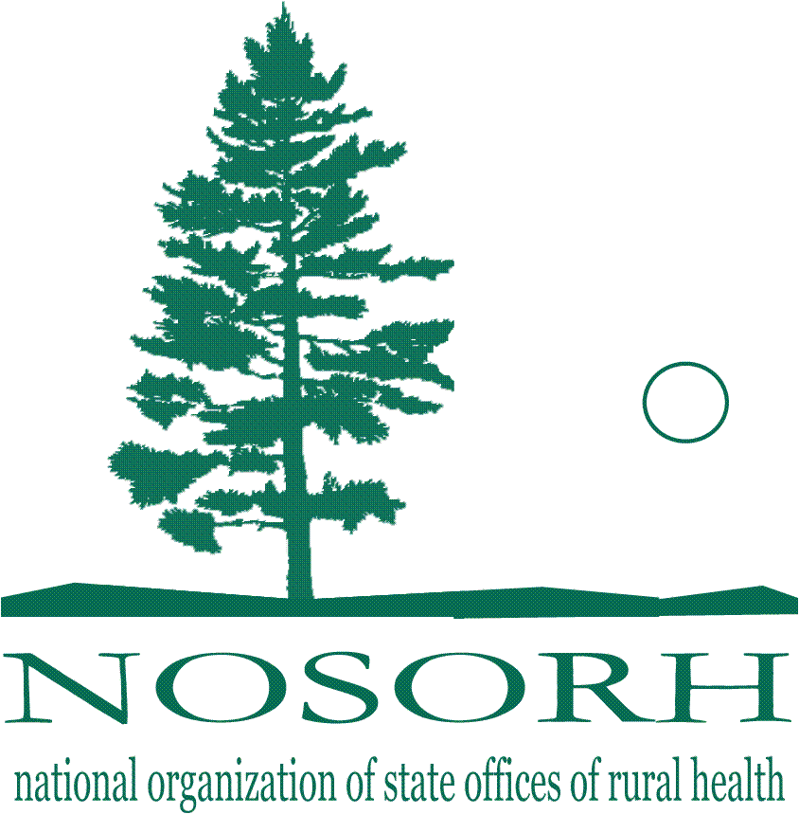
• 44648 Mound Road, #114 • Sterling Heights, MI 48314-1322 •
• Phone: 586-739-9940 • Fax: 586-739-9941

July 15, 2011

I am writing on behalf of the National Organization of State Offices of Rural Health (NOSORH) and the millions of rural residents we work with each year.

It has come to our attention that as part of the ongoing debate on reducing our nation’s long-term spending, a proposal has been put forward that would cut Medicare payments to rural hospitals by $14 Billion over the next 10 years. It has also been reported that an additional $2 billion might be cut from so-called “frontier” programs. We believe such cuts would be devastating to not only rural hospitals, but the millions of Medicare recipients who reside in rural or frontier areas.

As you know, rural communities have a disproportionately high percentage of Medicare and Medicaid recipients as a percentage of their total population when compared to urban or suburban areas. This means that healthcare providers – hospitals, critical access hospitals, rural health clinics, physicians, nursing homes, home health agencies, etc. – are highly dependent on receiving adequate Medicare and Medicaid payments for their economic survival. Over the years, Congress has seen fit to provide additional reimbursements or enhanced payments from Medicare and Medicaid to rural providers to ensure that they had the revenues necessary to survive.

Any effort to cut rural provider payments from Medicare or Medicaid – hospitals, physicians, critical access hospitals, rural health clinics, federally qualified health centers, etc. – must be rejected.

We are also aware that as part of the debt limit debate, Congress may be contemplating major cuts in domestic discretionary spending. We want to also urge caution in this area as well. There are a number of small, efficient and highly effective federal programs that help serve some of the unique needs of rural communities.

As was previously noted, rural areas have a disproportionately high percentage of low-income and elderly individuals residing in our communities compared to more urbanized areas. Rural communities are also characterized by low population density which translates into smaller tax bases. Because of the higher than average consumption of health care and the lower than average generation of local tax dollars, rural communities have a greater demand for assistance from federal grant programs.

As you consider changes in both entitlement programs and domestic discretionary spending, we strongly urge you to consider the unique situation surrounding rural residents and the cost and availability of health care. Please do all you can to ensure that rural health providers, their patients and the federal programs that help make health care accessible and affordable in rural America are not harmed.

If you have any questions or need any additional information, please do not hesitate to contact our Director, Teryl Eisinger at: teryle@nosorh.org

